Defect id: 03

Description:

* App is crashing when clicked on ‘History’ and ‘Nearby’ button

Severity:

* Critical

Priority:

* High

Steps to Reproduce:

1. Navigate to Home page
2. Click on ‘History’ or ‘Nearby’ button

Actual Result:

* App is crashing

Expected Result:

* App should be navigated to the respective pages

Environment:

* Android 10 Virtual device using Android Studio on Windows

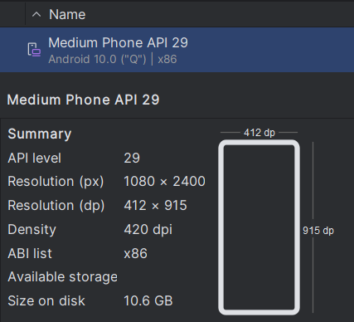

Evidence:



